**Loan Approval Analysis Using Power BI**

DASHBOARD 1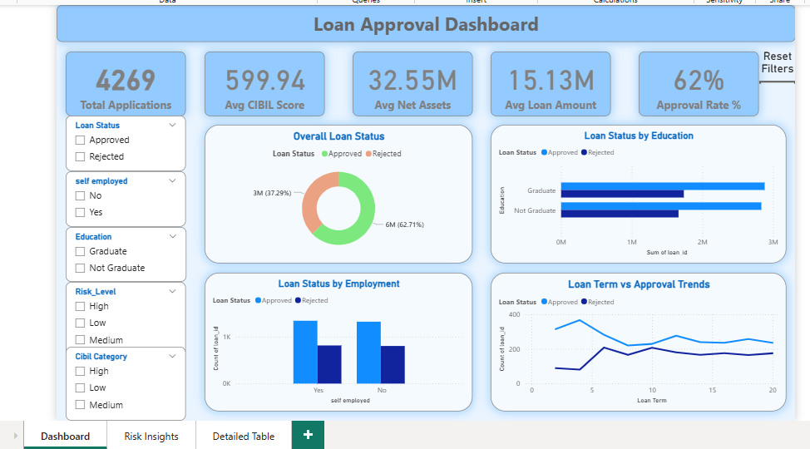

DASHBOARD 2

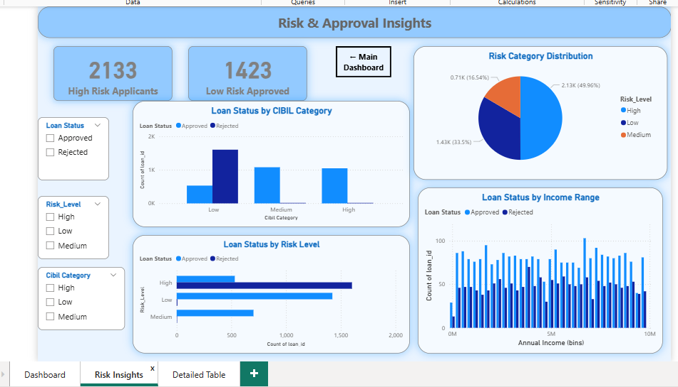

DASHBOARD 3

